Sponsorship

Introduction

The World’s Toughest Row is not only a physical and mental challenge, but a logistical one. Overall costs to fund such an endeavour is in order of £100k. Most of this comes from the ocean rowing vessel needed to cross an ocean which can be about 55% to 65% of the total costs.

Hence, getting to the actual start line of the race in La Gomera can be thought as being much harder than rowing across the ocean itself. Over 30 crews (100 rowers) each year compete in the Atlantic race thanks to generous support from corporate sponsorships which not only allow crews to race and achieve their dreams, but also support charities the crews are fundraising for.

As a commitment to the Atlantic challenge, I am self-funding the cost of the boat (£65,595). This boat is an R25 from Rannoch Adventure and I have bought one brand new from them and will be collecting it in April 2024. The boat will be very bare bones and the cost exclude oars and I will need key survival kit such as lifejackets, harnesses, survival locator beacons and handheld radios.

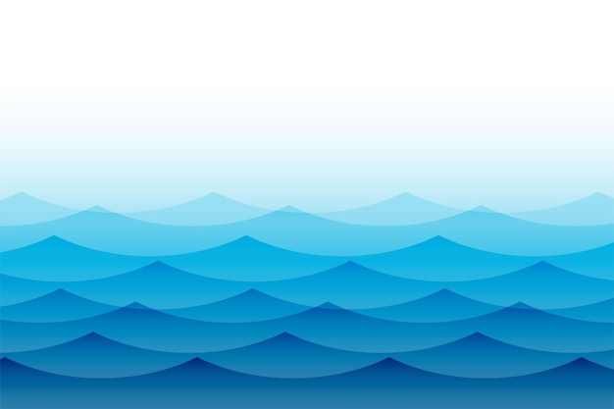Your support will be greatly appreciated and will allow me to fully focus on the physical and technical aspects of ocean rowing. My time at Bradford Amateur Rowing Club has been the catalyst for my competitive spirit. If I get to La Gomera in 2025, I will be aiming to cross the Atlantic in a competitive time rowing more than 16 hours daily for over the course of the race.

Sponsorship

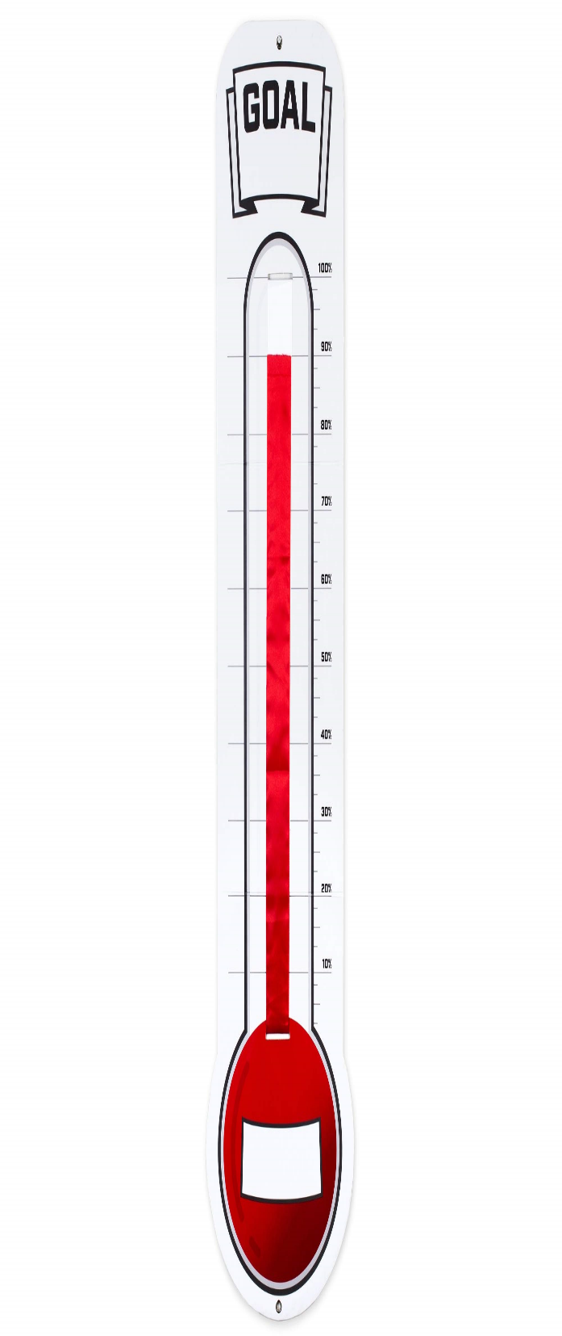

Sponsorship Targets:

First Milestone: £2500:

At this milestone, I will be able berth the boat at Hartlepool Marina which will allow me to train in the bay. Rowers are required to 120 Hours minimum, 24 hours in darkness and one outing over 36 hours. However, the more I can do from May 2024 to October 2025, the greater mastery I will have over the boat and equipment to cross the Atlantic in a safe and quick manner.

Second Milestone: £10,000:

At this milestone, I will be able to prepare all the food I will need for the crossing and all the equipment that will be needed. The organizer’s safety team enforce a 100 days’ worth of food for solo rowers and rowers can burn an excess of 5000 calories a day which is large amount of ration packs.

Third Milestone: £30,000:

At this milestone, I will be able to officially enter the race and be able to travel and stay in La Gomera and Antigua.

Fourth Milestone: £45,000:

At this milestone, I will be able to ship the boat from the UK to La Gomera and back to the UK from Antigua.

Final Milestone: £110,000:

At this milestone, the cost of the boat will be paid off and I will be able to donate 100% of the sale of the boat to the River’s Trust charity to which I am supporting.

Sponsorship

Sponsorship Tiers:What I can do for my sponsors at different levels of support.

|  |  |  |  |  |  |
| --- | --- | --- | --- | --- | --- |
| Wave Header Images – Browse 119,361 Stock Photos, Vectors ...  **Branding and Engagement** | **Diamond Tier**  **(Over £25,000)** | **Gold Tier**  **(From £10,000 to £25,000** | **Silver Tier**  **(From £2,500 to £10,000** | **Bronze Tier**  **(From £1,000 to £2,500** | **£250 Club** |
| **Branding on Flag pole up to Atlantic race** | **#1 Sponsor** | **#1 Sponsor** | **#1 Sponsor** | **#1 Sponsor** | **#1 Sponsor** |
| **Logo Link to your Website on QR code Linkedtr.ee** | **Top 3 Sponsors** | **Top 3 Sponsors** | **Top 3 Sponsors** | **Top 3 Sponsors** | **Top 3 Sponsors** |
| **Outside Shell Boat Branding** | **Logo size**  **(2500 Units Squared)**  **(Highest Priority**  **Location choice)**  **Green checked checkbox icon - Free green check mark icons** | **Logo size**  **(1000 Units Squared)**  **Green checked checkbox icon - Free green check mark icons** | **Logo size**  **(250 Units Squared)**  **Green checked checkbox icon - Free green check mark icons** | **Logo size**  **(100 Units Squared)**  **Green checked checkbox icon - Free green check mark icons** | **Logo size**  **(2 Units Squared)**  **(One Side only)**  **Green checked checkbox icon - Free green check mark icons** |
| **Cabin Door Boat Branding** | **Green checked checkbox icon - Free green check mark icons** | **Green checked checkbox icon - Free green check mark icons** | **Green checked checkbox icon - Free green check mark icons** | Checkbox Cross Red icon PNG and SVG Vector Free Download | Checkbox Cross Red icon PNG and SVG Vector Free Download |
| **Inside Cabin Branding** | **Green checked checkbox icon - Free green check mark icons** | **Green checked checkbox icon - Free green check mark icons** | **Green checked checkbox icon - Free green check mark icons** | **Green checked checkbox icon - Free green check mark icons** | **Green checked checkbox icon - Free green check mark icons** |
| **Name on interior of Boat Shell** | **Green checked checkbox icon - Free green check mark icons** | **Green checked checkbox icon - Free green check mark icons** | **Green checked checkbox icon - Free green check mark icons** | **Green checked checkbox icon - Free green check mark icons** | **Green checked checkbox icon - Free green check mark icons** |
| **Branding on the Oars** | **Green checked checkbox icon - Free green check mark icons** | Checkbox Cross Red icon PNG and SVG Vector Free Download | Checkbox Cross Red icon PNG and SVG Vector Free Download | Checkbox Cross Red icon PNG and SVG Vector Free Download | Checkbox Cross Red icon PNG and SVG Vector Free Download |
| **Branding on every page on the website**  **With hyperlinks** | **Green checked checkbox icon - Free green check mark icons** | **Green checked checkbox icon - Free green check mark icons** | Checkbox Cross Red icon PNG and SVG Vector Free Download | Checkbox Cross Red icon PNG and SVG Vector Free Download | Checkbox Cross Red icon PNG and SVG Vector Free Download |
| **Branding on home Page on Website with hyperlinks.** | **Green checked checkbox icon - Free green check mark icons** | **Green checked checkbox icon - Free green check mark icons** | **Green checked checkbox icon - Free green check mark icons** | **Green checked checkbox icon - Free green check mark icons** | **Name only**  **Green checked checkbox icon - Free green check mark icons** |
| **Branding on T-shirt** | **Logo size**  **(400 Units Squared)**  **Green checked checkbox icon - Free green check mark icons(Your location choice)** | **Logo size**  **(200 Units Squared)**  **Green checked checkbox icon - Free green check mark icons** | **Logo size**  **(100 Units Squared)**  **Green checked checkbox icon - Free green check mark icons** | Checkbox Cross Red icon PNG and SVG Vector Free Download | Checkbox Cross Red icon PNG and SVG Vector Free Download |
| **Branding on First Page of any future talks** | **Green checked checkbox icon - Free green check mark icons** | Checkbox Cross Red icon PNG and SVG Vector Free Download | Checkbox Cross Red icon PNG and SVG Vector Free Download | Checkbox Cross Red icon PNG and SVG Vector Free Download | Checkbox Cross Red icon PNG and SVG Vector Free Download |
| **Branding on last page of any future talks** | **Alterning on every row and column**  **Green checked checkbox icon - Free green check mark icons** | **Alternating on every odd row and column**  **Green checked checkbox icon - Free green check mark icons** | **Green checked checkbox icon - Free green check mark iconsEvery other space not taken by gold and diamond tier.** | **Green checked checkbox icon - Free green check mark iconsEvery other space not taken by gold and diamond tier.** | Checkbox Cross Red icon PNG and SVG Vector Free Download |
| **Tag Mention on all Social Media Posts** | **Green checked checkbox icon - Free green check mark icons** | **Green checked checkbox icon - Free green check mark icons** | Checkbox Cross Red icon PNG and SVG Vector Free Download | Checkbox Cross Red icon PNG and SVG Vector Free Download | Checkbox Cross Red icon PNG and SVG Vector Free Download |
| **Special Social Media Post of your branding after sponsoring the campaign** | **Green checked checkbox icon - Free green check mark iconsPinned to top of social media until end of campaign** | **Green checked checkbox icon - Free green check mark icons** | **Green checked checkbox icon - Free green check mark icons** | **Green checked checkbox icon - Free green check mark icons** | **Green checked checkbox icon - Free green check mark iconsCollective group mention every 6 months** |
| **Branding on Posters** | **Green checked checkbox icon - Free green check mark icons** | **Green checked checkbox icon - Free green check mark icons** | Checkbox Cross Red icon PNG and SVG Vector Free Download | Checkbox Cross Red icon PNG and SVG Vector Free Download | Checkbox Cross Red icon PNG and SVG Vector Free Download |
| **Branding on Banners** | **Logo size**  **(400 Units Squared)**  **(Highest Priority**  **Location choice)**  **Green checked checkbox icon - Free green check mark icons** | **Logo size**  **(200 Units Squared)**  **Green checked checkbox icon - Free green check mark icons** | **Logo size**  **(100 Units Squared)**  **Green checked checkbox icon - Free green check mark icons** | **Logo size**  **(50 Units Squared)**  **Green checked checkbox icon - Free green check mark icons** | **Logo size**  **(25 Units Squared)**  **Green checked checkbox icon - Free green check mark icons** |



Sponsorship templates: Rough guides (Not to scale)

Cabin Door Branding

Cabin Door Branding

Inner shell boat branding

Sponsor



Outer Boat Shell Branding

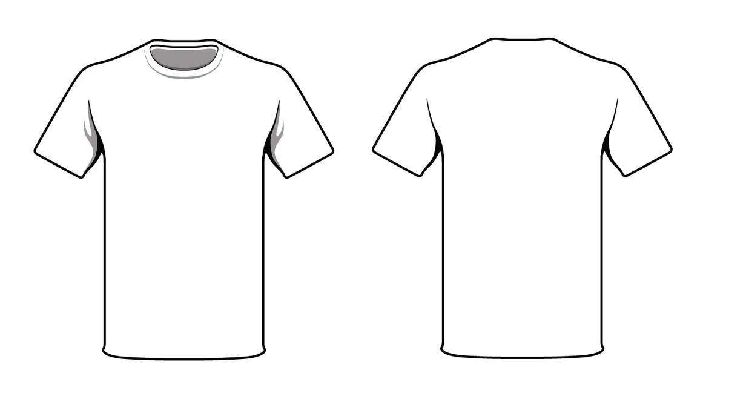

About Us |

Jake Still

Sponsor

Rowing in the

worldstoughestrow.com – The World's Toughest Row

Dec 2025







What I will be doing:

Showcases: I plan to display my boat in various places around Pudsey, Shipley and Baildon. The showcases will be about talking to locals about my Atlantic campaign with banners and the boat shell acting as advertisement for local businesses in West Yorkshire. Showcases at Farsley Festival and Baildon Carnival and at Sunny Bank mill, 20,000+ people in total.

Videos: I will be documenting everything that I do once I acquire the boat. Making video shorts of my journey. The lifestyle of ocean rowing, how I am training, what I am eating, how I go through tidal lock at Hartlepool Marina, navigating at night etc. These videos will appear on YouTube, Instagram and TikTok. Such things will include drawing shapes on GPS tracker to not only practise with navigation but build cool stories.

Local Media: Currently working with James Bowling on telling my story on the Squeaker which is local journalism around West Leeds. 15,000+ copies around Leeds.

Talks: I also plan to arrange talks about my journey and crossing to the rowing clubs within the Yorkshire region as well as local Scouting groups within Leeds.

Data and social media: I will also be keeping my data collection going on my distance rowed, the calories burned and represent these graphically as bar charts and geo-spatial mapping of what those numbers would like across the Atlantic. These posts will appear on my Instagram, Facebook, my Website and my LinkedIn.

Posters and Banners: I will be placing a banner outside of my clubhouse advertising the campaign as well as showing these in front of the boat showcases.

Blog: Got a blog going on the Rivers Trust which is the charity partner I am working with. Approximately 27,000+ national social media reach.